Nov. 13, 2024

**LIGHTS! MUSIC! MAGIC!**

**ABC 7 CHICAGO KICKS OFF THE HOLIDAY SEASON NATIONWIDE WITH THE BROADCAST OF THE WINTRUST MAGNIFICENT MILE LIGHTS FESTIVALHOSTED BY CHERYL BURTON AND RYAN CHIAVERINI SUNDAY, NOV. 24, AT 6 P.M.**

**2024 Marks the 33rd Year Wintrust Magnificent Mile Lights Festival on**

**Chicago’s Michigan Avenue**

**Featuring Grand Marshals Mickey Mouse and Minnie Mouse From Walt Disney World Resort****in Florida**

**Special Performances Atop Chicago’s Iconic Wrigley Building Include Tony Award-Winning Singer/Actress, Heather Headley and Singer Virginia Bocelli; Iconic Disco Group the Former Ladies of Chic and Funk Band Cameo**

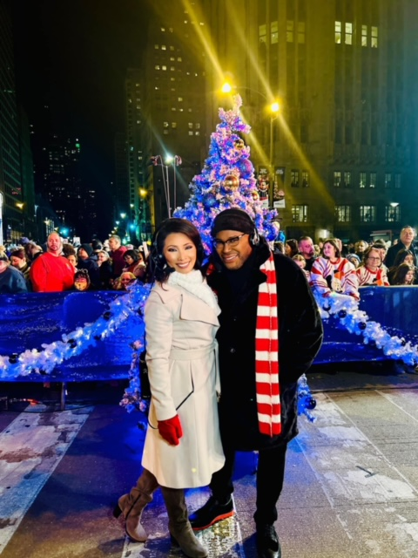

Hosts Ryan Chiaverini, Cheryl Burton, Judy Hsu and Hosea Sanders

The magic of the holidays, Chicago style is captured for viewers around the country with spectacular entertainment, beloved characters from Walt Disney World Resort®, luminous floats, Santa and dazzling fireworks as more than a million twinkling Michigan Avenue lights set the stage for the broadcast of the fantastic Wintrust Magnificent Mile Lights Festival®, airing Sunday, Nov. 24, from 6-7 p.m. on ABC 7 Chicago. Encore broadcasts will air Sunday, Dec. 1, at 3 p.m.; Sunday, Dec. 8, at 4 p.m.; and Sunday, Dec. 15, at 11 p.m.

The Wintrust Magnificent Mile Lights Festival steps off on Oak Street and travels down Michigan Avenue on Saturday, Nov. 23 at 5:30 p.m. ABC 7 Eyewitness News anchors Cheryl Burton and Ryan Chiaverini will serve as co-hosts of the broadcast along with ABC 7’s Judy Hsu and Hosea Sanders, who bring sparkle and excitement reporting street side.

The Wintrust Magnificent Mile Lights Festival Parade will be available on demand and stream on abc7chicago.com and ABC 7’s Connected TV Apps on Amazon Fire TV, Android TV, Apple TV and Roku.

Dazzling audiences with a star-studded lineup, the country’s largest evening holiday celebration will light up the top of Chicago’s iconic Wrigley building with song, featuring Tony® Award-winning actress Heather Headley, performing “Thankful”; and Virginia Bocelli, daughter of famous tenor Andrea Bocelli, singing “Over the Rainbow.”

Parade attendees and viewers alike will be singing along with the iconic disco group, the former Ladies of Chic, performing hits “Le Freak” and “Good Times.” American soul-influenced funk band Cameo will keep the holiday spirit groove going when they perform “Word Up!” and “Candy,” and The Wintrust Express will feature ‘90s Miami Bass duo Quad City DJ’s keeping the mood high while performing “C’mon N’ Ride It (The Train)” and “Space Jam”; and Choose Chicago will highlight the 40th anniversary of House Music with a performance from DJ Chip E.

In the first official parade of the holidays, grand marshals Mickey Mouse and Minnie Mouse, from Walt Disney World Resort will illuminate over 1 million twinkling lights on 200 trees along “The Magnificent Mile.” As they light each block along the way, Mickey and Minnie will take time to greet kids of all ages. Soaring alongside Chicago’s spectacular architecture on Michigan Avenue will be the Muppet balloons, including the super-colossal 60-foot-tall Kermit the Frog Santa and his pal Animal. Coming down Michigan to delight all will be everyone’s favorite reindeer—Rudolph! Special Olympics Illinois is thrilled to bring Rudolph the Red-Nosed Reindeer to the Wintrust Magnificent Mile Lights Festival again this year. Just like Rudolph, who showed that being a little different makes all the difference, Special Olympics Illinois celebrates the unique abilities of everyone in its community.

The world’s most beloved Disney characters including Buzz Lightyear, Woody, Anna, Elsa, Tiana and Belle will be front and center, appearing on awe-inspiring themed floats. Marching bands from around the country, in addition to returning fan favorites like the Crystal Lake Strikers Drumline, will bring the thrill of drums beating down the Mag Mile.

This is the 16th consecutive year the much-anticipated tradition will be broadcast to Chicago audiences on ABC 7, the most-watched television station in the city. Throughout the holiday season, the special will also be watched in more than 200 U.S. markets throughout the holiday season, reaching nearly 100% of the country plus Toronto, Canada, with encore airings in multiple markets. Check local listings for times.

Members of the ABC 7 Eyewitness News team will be spreading good cheer along Michigan Avenue on ABC 7 Chicago’s whimsical float.

As Santa makes his exciting arrival on the scene while waving from a beautiful float, the broadcast’s grand finale will light up the sky (and children’s hearts) with The Wintrust Fireworks Spectacular—a dazzling display over the Chicago River, along with brilliant new lighting made possible by Enjoy Illinois.

**About ABC7/WLS-TV Chicago**

ABC7/WLS-TV Chicago is the No. 1 local news source and most-watched television station in Chicago. With top-rated daily newscasts spanning decades and the largest social media presence in the market with more than 2.6 million Facebook followers, ABC7 Eyewitness News provides breaking news, investigative reporting, weather, politics, traffic and sports in the multiplatform space to Chicago, the suburbs and northwest Indiana. Named *Best News Operation* by the Associated Press for four consecutive years, ABC 7 Eyewitness News produces “Chicago Proud,” a series of features that spotlights everyday heroes in and around Chicago. The station also produces the highest-rated New Year’s Eve special in Chicago, holiday kickoff special “The Magnificent Mile Lights Festival,” syndicated to a national audience, as well as the award-winning program series “Our Chicago,” which showcases the city’s diversity and highlights contributions in the Black, Hispanic, Asian, LGBTQ+ communities, among others. Every Friday, Windy City Weekend, entertains while giving Chicagoans everything they need to know about what’s happening in the city. ABC 7 is the only Chicago station producing and broadcasting parades representing Chicago’s rich cultural history. In addition to producing town halls focused on current social issues, the station has a long and proud tradition of broadcasting political candidate debates keeping Chicago’s electorate informed. ABC7’s outreach efforts include annual partnerships with the Red Cross for life-saving blood drives, one of the biggest one-day drives in the country and, most recently, spearheading an effort to raise more than $1.5 million for area food pantries.

Follow **ABC7/WLS-TV Chicago** on [Instagram](https://www.instagram.com/abc7Chicago/) and [Facebook](https://www.facebook.com/abc7Chicago/).

**Media Contact:**

Jayme Nicholas

(312) 750-7254

[jayme.a.nicholas@abc.com](mailto:jayme.a.nicholas@abc.com)

**-- WLS --**