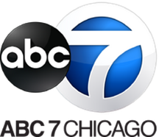

June 17, 2024

ABC 7 CHICAGO CELEBRATES PRIDE WITH LIVE BROADCAST FROM
THE 53RD ANNUAL PRIDE PARADE
SUNDAY, JUNE 30, AT 11 A.M. ON ABC7 AND ABC7CHICAGO.COM

Will Also Exclusively Stream Live on ABC 7’s Connected TV Apps on Amazon Fire TV,
Android TV, Apple TV, Roku and ABC News Live on Hulu

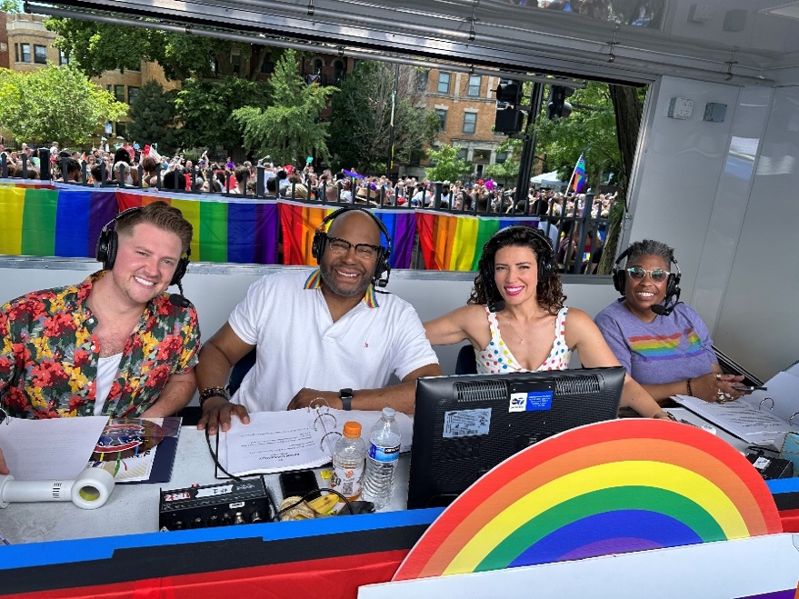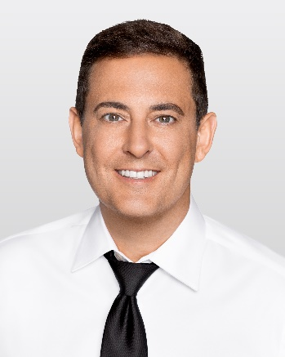
Hosts Cody LaGrow, ABC 7’s Hosea Sanders and Tanja Babich, and Kim Hunt along with ABC 7’s Jason Knowles, reporting live on the street.

ABC 7 celebrates the 53rd Annual Chicago Pride Parade with a two-hour, live parade broadcast, Sunday, June 30, from 11:00 a.m. to 1:00 p.m. ABC 7’s Tanja Babich, Hosea Sanders and Jason Knowles host the Chicago Pride Parade broadcast with Knowles capturing all the action live from the street. LGBTQIA+ community advocates join the festivities, including Cody LaGrow (Emmy® Award-winning journalist), Kim Hunt (Chicago LGBT Hall of Fame and senior director of AIDS Initiative Chicago).

The parade will also exclusively stream on ABC 7’s Connected TV Apps on Amazon Fire TV, Android TV, Apple TV, Roku and ABC News Live on Hulu.

Members of the ABC 7 Chicago Eyewitness News team including Ravi Baichwal, Rob Elgas, Jasmine Minor and Tre Ward are scheduled to ride on the ABC 7 float.

“ABC 7 is proud of our long-standing commitment to Pride, and we are thrilled again to be the station presenting two hours of live parade coverage on multiple platforms,” said John Idler, president and general manager of ABC 7 Chicago. “ABC 7 celebrates cultural inclusion and acceptance and the vibrant LGBTQAI+ community that is so important to our city.”

The 53rd Annual Pride Parade features actress, writer and comedian Fortune Feimster as this year’s grand marshal. The 2024 parade theme is “Pride is Power.” The Pride Parade kicks off this year from Sheridan and Broadway, travels through the Northhalsted, Uptown, Lakeview and Lincoln Park neighborhoods and ends on Cannon Drive. The parade features colorful floats, decorated vehicles, musical talent, walking contingents and local government officials all in support of the LGBTQAI+ community.

ABC News Live’s Pride Parade coverage kicked off with a simulcast of KABC-TV’s coverage of LA Pride on June 9 and will culminate with “Pride Across America,” a major streaming event that spans the entire country, featuring five hours of live coverage from three of the nation’s biggest Pride marches and parades on June 30, beginning at 11 a.m. EDT/8 a.m. PDT. In partnership with Hulu and ABC Owned Television Stations WABC (New York), WLS (Chicago) and KGO (San Francisco), “Pride Across America” will begin with a one-hour pre-show, followed by coverage of the Pride marches and parades, and will include live special guest interviews and inspiring stories, spotlighting today’s influential LGBTQIA+ leaders.

The annual parade celebration commemorates the Stonewall Riots, which occurred June 28, 1969, in the Greenwich Village neighborhood of New York City. Chicago’s Pride Parade takes place the same weekend in the summer, replacing what was once a fight for civil rights with dazzling displays of hope and perseverance.

About ABC7/WLS-TV Chicago
ABC7/WLS-TV Chicago is the No. 1 local news source and most-watched television station in Chicago. With top-rated daily newscasts spanning decades and the largest social media presence in the market with more than 2.6 million Facebook followers, ABC7 Eyewitness News provides breaking news, investigative reporting, weather, politics, traffic and sports in the multiplatform space to Chicago, the suburbs and northwest Indiana. Named Best News Operation by the Associated Press for four consecutive years, ABC 7 Eyewitness News produces “Chicago Proud,” a series of features that spotlights everyday heroes in and around Chicago. The station also produces the highest-rated New Year’s Eve special in Chicago, holiday kickoff special “The Magnificent Mile Lights Festival,” syndicated to a national audience, as well as the award-winning program series “Our Chicago,” which showcases the city’s diversity and highlights contributions in the Black, Hispanic, Asian, LGBTQ+ communities, among others. Every Friday, Windy City Weekend, entertains while giving Chicagoans everything they need to know about what’s happening in the city. ABC 7 is the only Chicago station producing and broadcasting parades representing Chicago’s rich cultural history. In addition to producing town halls focused on current social issues, the station has a long and proud tradition of broadcasting political candidate debates keeping Chicago’s electorate informed. ABC7’s outreach efforts include annual partnerships with the Red Cross for life-saving blood drives, one of the biggest one-day drives in the country and, most recently, spearheading an effort to raise more than $1.5 million for area food pantries.

X: https://twitter.com/abc7chicago
Instagram: https://www.instagram.com/abc7Chicago/
Facebook: https://www.facebook.com/abc7Chicago/

Media Contact:
Jayme Nicholas
(312) 750-7254
jayme.a.nicholas@abc.com

-- WLS --

