Nov. 3, 2022

ABC OWNED TELEVISION STATIONS HONOR NATIVE SOVEREIGNTY IN NEW DOCUMENTARY IN PARTNERSHIP WITH NATIONAL GEOGRAPHIC,
‘OUR AMERICA: RECLAIMING TURTLE ISLAND’

Documentary Features Prominent Indigenous Voices Including Model and Activist,
Quannah Rose Chasinghorse, and Artist and Black Eyed Peas Band Member Taboo

Special Is Based on Cover Story in July 2022 Issue of National Geographic Magazine,
‘We Are Here’

First Preview Clip Debuts Today, Nov. 3, in Commemoration of Native American Heritage Month; Full Documentary Airs Later this Month

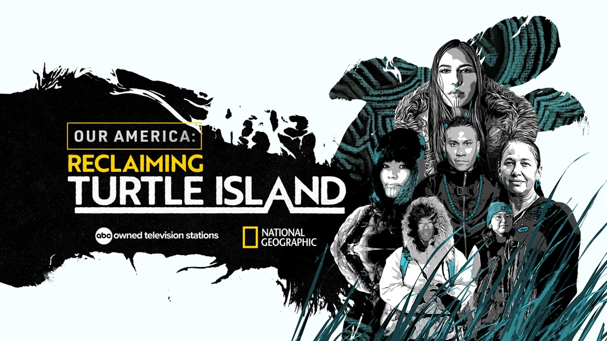

WATCH AN EARLY CLIP FEATURING TRADITIONAL CORN GROWER ANGELA FERGUSON DISCUSSING THE IMPORTANCE OF FOOD SOVEREIGNTY AND LEARN MORE HERE

SHARE CLIP HERE

VISUALS AND INTERVIEWS AVAILABLE UPON REQUEST

KEY ART HERE

To raise awareness and elevate the conversation around Native American sovereignty, ABC Owned Television Stations have produced "Our America: Reclaiming Turtle Island,” with an early clip now available, commemorating Native American Heritage Month this November. The documentary will be available on November 18 at reclaimingturtleisland.abc.

The documentary special will debut beginning Nov. 19-20 on linear across eight ABC stations ABC7/WABC-TV New York, ABC7/KABC-TV Los Angeles, ABC7/WLS-TV Chicago, 6ABC/WPVI-TV Philadelphia, ABC7/KGO-TV San Francisco, ABC13/KTRK-TV Houston, ABC11/WTVD-TV Raleigh-Durham and ABC30/KFSN-TV Fresno, its 24/7 streaming platforms, 32 connected TV apps across streaming platforms Amazon Fire TV, Apple TV, Android TV, Roku and available on Hulu November 25, Native American Heritage Day.

"Our America: Reclaiming Turtle Island” is an hourlong documentary special that will inform viewers about Native sovereignty, the inherent authority of American tribes to govern themselves and honor and preserve their cultures and traditions. Told through the lens and imagery of National Geographic Explorer and photographer Kiliii Yüyan, the special is produced by Nzinga Blake, Race and Culture executive producer at ABC Owned Television Stations, and edited by Tracy Quezada.

The documentary brings to life the July 2022 cover story for National Geographic magazine, “We Are Here,” with text by Charles C. Mann and photography by Yüyan, and features powerful individuals discussing the strides their nations and communities are taking to reclaim Turtle Island - a common Indigenous name for North America. Featured in the documentary are Taboo, a cultural activist Marvel comic creator, writer, and global music icon known for 1/3 of the pop group Black Eyed Peas; Quannah Rose Chasinghorse, a model and activist known for appearing on the 2020 Teen Vogue list of Top 21 under 21 and more; Jody Potts-Joseph, traditional tattoo practitioner and subject of the National Geographic series “Life Below Zero: First Alaskans”; historian and Native American artist G. Peter Jemison, whose art is featured in the documentary; and traditional corn grower Angela Ferguson.

The special will begin with Taboo reading the creation story about the origin of how and why North America is referred to as Turtle Island. Viewers will then journey from Minnesota to Southern California and then Western New York, connecting with tribes and Native American changemakers as they define what Native Sovereignty means to them and share how they are contributing to the movement through their platforms and activism.

The ABC Owned Television Stations, which collectively reach 23% of households across all U.S. television, have made a commitment to produce high-impact content representing various voices within communities and newsrooms across the country. “Our America: Reclaiming Turtle Island” will aim to inform and serve those underrepresented in the United States today by amplifying the voices of the Indigenous activists featured in the documentary.

“We hope that with this special event, we will continue the elevation of the Native American culture, and both educate and inspire current and future generations to come, including those audiences unfamiliar with the history and culture of Native indigenous communities,” said Chad Matthews, President, ABC Owned Television Stations.

In addition, ABC Owned Television Stations has partnered with the Described and Captioned Media Program (DCMP.org) to make “Our America: Reclaiming Turtle Island” accessible to blind and deaf audiences through audio description and captions. The DCMP has been committed to making quality educational programming accessible through audio description for over 30 years.

To learn more about Native American sovereignty and view the preview for “Our America: Reclaiming Turtle Island,” visit natgeo.com/nahm.

More information about ABC Owned Television Stations streaming channels can be found here: ABC7/WABC-TV New York, ABC7/KABC-TV Los Angeles, ABC7/WLS-TV Chicago, 6ABC/WPVI-TV Philadelphia, ABC7/KGO-TV San Francisco, ABC13/KTRK-TV Houston, ABC11/WTVD-TV Raleigh-Durham and ABC30/KFSN-TV Fresno.

For more on the July 2022 cover story by National Geographic, “We Are Here,” click HERE.

LINK TO KEY ART HERE

About ABC Owned Television Stations
Disney Media Entertainment & Distribution's eight owned ABC stations are multiplatform leaders in local news and information. Collectively No. 1 across all U.S. television, reaching 23% of households and more than 34 million Total Viewers and 62 million digital visitors a month, with a record of 2.2 billion minutes streamed, the eight stations are comprised of WABC-TV New York, KABC-TV Los Angeles, WLS-TV Chicago, WPVI-TV Philadelphia, KGO-TV San Francisco, KTRK-TV Houston, WTVD-TV Raleigh-Durham and KFSN-TV Fresno. WABC-New York has remained the No. 1 station in the country for 19 years.

Media Contacts:
Anna Kukelhaus
Director of Communications
National Geographic Media and ABC Owned Television Stations
(202) 258-8020
anna.kukelhaus@natgeo.com

Vanessa Abron
Account Manager, One35 Agency
(312) 480-9050
vanessa@one35agency.com

-- ABC Owned Television Stations --

