BIOGRAPHY

MICHAEL CARR

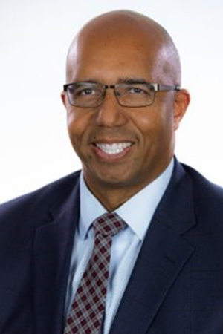
President and General Manager, KFSN-TV

Michael Carr is president and general manager of KFSN-TV, where he has overall management responsibility for KFSN-TV ABC30 and its ancillary businesses.

He previously worked as News Director at KFSN, where he oversaw content creation and operations for KFSN’s television, digital, and social media platforms. KFSN is the No. 1 source for local news in central California, both online, and on-air.

Carr has an extensive background in local TV journalism. He began his career as an intern at KFSN and has worked as an assignment editor, producer and executive producer prior to news director. In addition to Fresno, he has also worked in newsrooms in San Francisco and Sacramento.

He holds a bachelor’s degree in mass communication and journalism from California State University, Fresno, where he also played football for the Bulldogs. In 2017, Carr was named as a Fellow to the Fresno State Media, Communication and Journalism Department Hall of Fame. He is a member of the National Association of Black Journalists.

Mike and his wife DeAnn have two teenage daughters.

-- 2023 --

